Soft051 Coursework 1 (2014/2015): Chinese Numbers

**General Information**

Issue Date: Tuesday 11th November 2014  
**Due Date: Friday 19th December 2014 17:00 (on-line)**Return Date: Friday 6th February 2015  
Weighting: 25% of the module mark  
Contact: Mark Dixon  
 01752 586225  
 mark.dixon@plymouth.ac.uk

This is an individual assignment. However, my colleagues and I are available for guidance. Our aim is to help you without doing it for you.

It is not acceptable to work together on or share code that is submitted. Such activities are regarded as plagiarism and dealt with as academic offences. It is an offence to both use some else’s code and to supply others with code you have written. However, you may discuss all of the lecture material.

**Aim**

This assignment is intended to test your ability to apply the approaches, concepts, methods, and techniques covered so far in this module (such as HTML, conditional execution, loops, variables, arrays, and procedures).

**Objective**

You are required to design and implement a **prototype** game to help people learn to recognise the spoken Chinese words for the numbers 1 to 10.

You are advised to **stick tightly** to the **specification provided**. Any deviation from this specification should be discussed with the user (me).

*For the purposes of this assignment, I will act as your user (it is very important that you show me your work during tutorials). Each year a number of students fail because they misunderstand the brief and have not spoken to me.*

**Specification**

**Functional Specification**

The system should provide the following facilities:

F1.    **Start** – Your page should start by showing:  
 a title ‘Chinese Numbers’  
 a Play button  
 number buttons (1 to 10) – these should be disabled  
 an empty paragraph (for feedback)  
 a scoreboard (consisting of 5 grey stars)

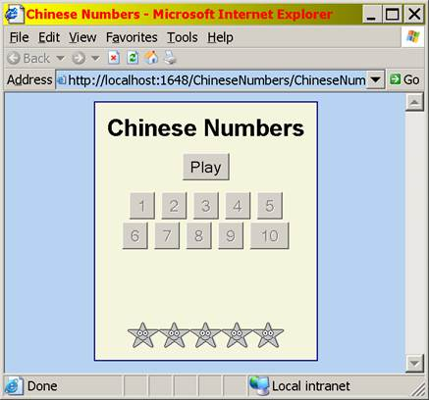

F2.    **Ask Question** – when the play button is clicked, the computer should:  
 pick a random number between 1 and 10  
 play the corresponding sound for the randomly selected number  
 (clicking the play button repeatedly should not change the number),  
 enable the number buttons

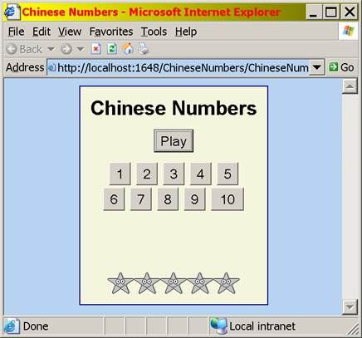

F3.    **Check Answer** – when any of the number buttons are clicked, the computer should compare the number with the correct answer:  
 F3.1 when the user’s answer is correct, the computer should:  
 play the sound corresponding to the button’s number  
 display a message saying ‘Correct’,  
 highlight the correct number button in green  
 disable the number buttons  
 update the score

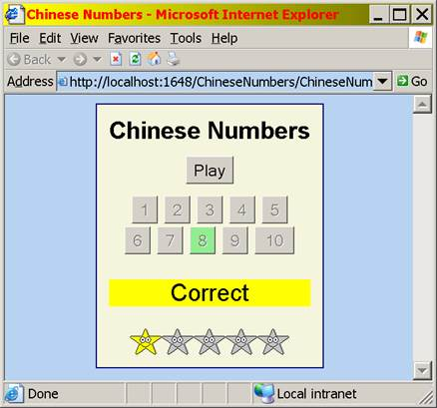

F3.2 when the user’s answer is wrong, the computer should:  
 play the sound corresponding to the button’s number  
 display a message giving the correct answer,  
 disable the number buttons  
 highlight the correct number in green,  
 highlight the number the user selected in red

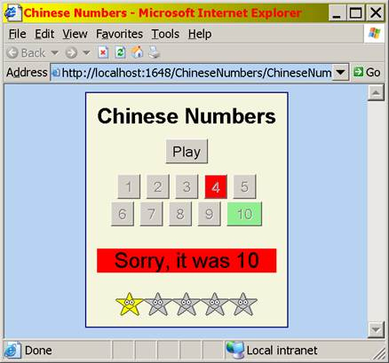

F4.    **Finish Game** – when the user has got 5 stars, the computer should:  
 display an alert box saying they have won the game

reset the state of the page back to what it was at the beginning  
 (without requiring the user to refresh the page)

F5.    **No Repeat** – The same number should not come up twice in succession.

**Deliverables**

You should submit the following (via the assignment upload facility within your **profile** on the web-site):

•    A single web-page with VBScript (no other programming language or version is acceptable).

•    All the files (sound, image, etc.) that this web-page needs to work.

Your work will be marked by **running it on the server**. Therefore, you should ensure your work functions properly on the server by clicking on your uploaded web-page (from machines in SMB109 using IE11).

If you upload the same file twice, the last file uploaded will replace the old one (I would encourage you to upload early and then re-upload newer versions as you develop your work). You can also delete files.

**Assessment Criteria**

The following marking scheme will be used (subject to moderation):

F1 5  
F2 10  
F3 10  
F4 3  
F5 2  
Code Design 20  
**TOTAL 50**

Quality is more important than quantity:

•      Something that attempts to do everything, but with nothing working is likely to receive a fail grade.

•      Something that does most things (but with lots of lines of code) is likely to pass.

•      Something that does most things (with fewer lines of code) is likely to receive a higher grade.

It is generally better to get each part working before you move on to the next.